**Airplane mode by Sikuli Script of Wireless WAN automated testing**

**Version 1.0**

**Version History**

|  |  |  |  |
| --- | --- | --- | --- |
| **Version** | **Date** | **Handled by** | **Comments** |
| V1.0 | 05-Dec-2019 | ZL Chen | First version release. |

Precondition Setting:

Please make sure the DUT is connected to the internet.

* Install the Python 3.6.8.
  + Please refer to the “Python 3.6.8 installation.pdf” attachment.

(\automation\sop\other\Python 3.6.8 installation.pdf)

* Install the Sikuli-IDE.
  + Please refer to the “Sikuli X r930 installation.pdf”attachment.

(\automation\sop\sikuli_x\Sikuli X r930 installation.pdf)

* Install the third party library.
  + Double click the “Envir_Install.exe” under the installer folder.

(\automation\installer\Envir_Install.exe)

Please follow the implement as below:

Step 1:

Please make sure the WAN is connecting to the repeater.

Step 2:

Please delete all of the known networks, because you need make sure the network just only attach to the WAN server.

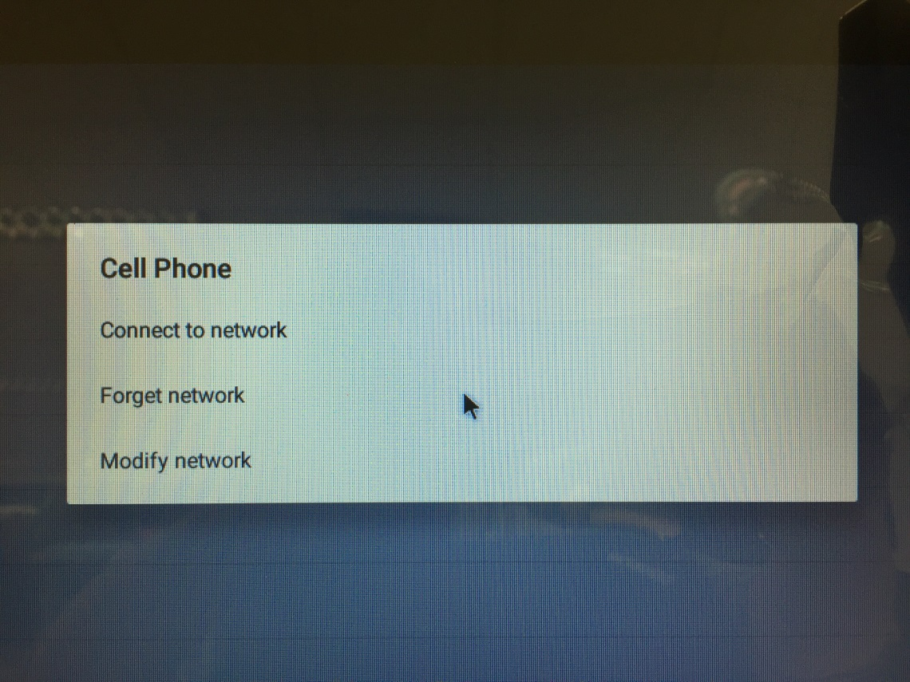

Step 3:

Join the Path:

%SystemRoot%\System32\WindowsPowerShell\v1.0\

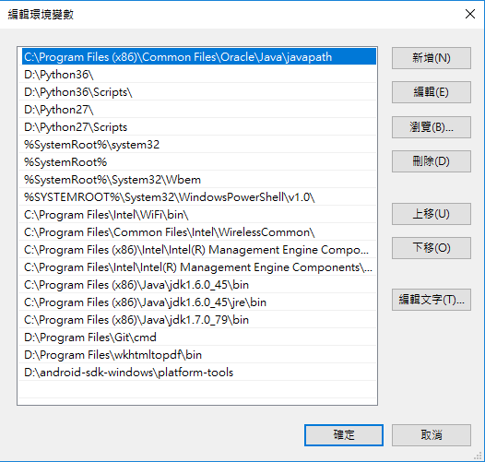

Step 4:

Please copy the \windows\airplane\ folder of the suite to the device’s desktop.

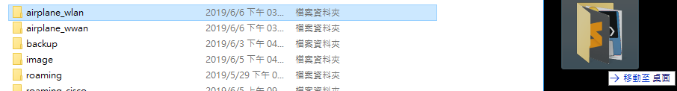

Implement the airplane_wwan_windows_sikuli.pyc under the “\airplane_wwan\” folder.

Step 5:

Please input the “Cycle Times” and “Gateway” you want, and then tap the “Enter”.

The program is start running.

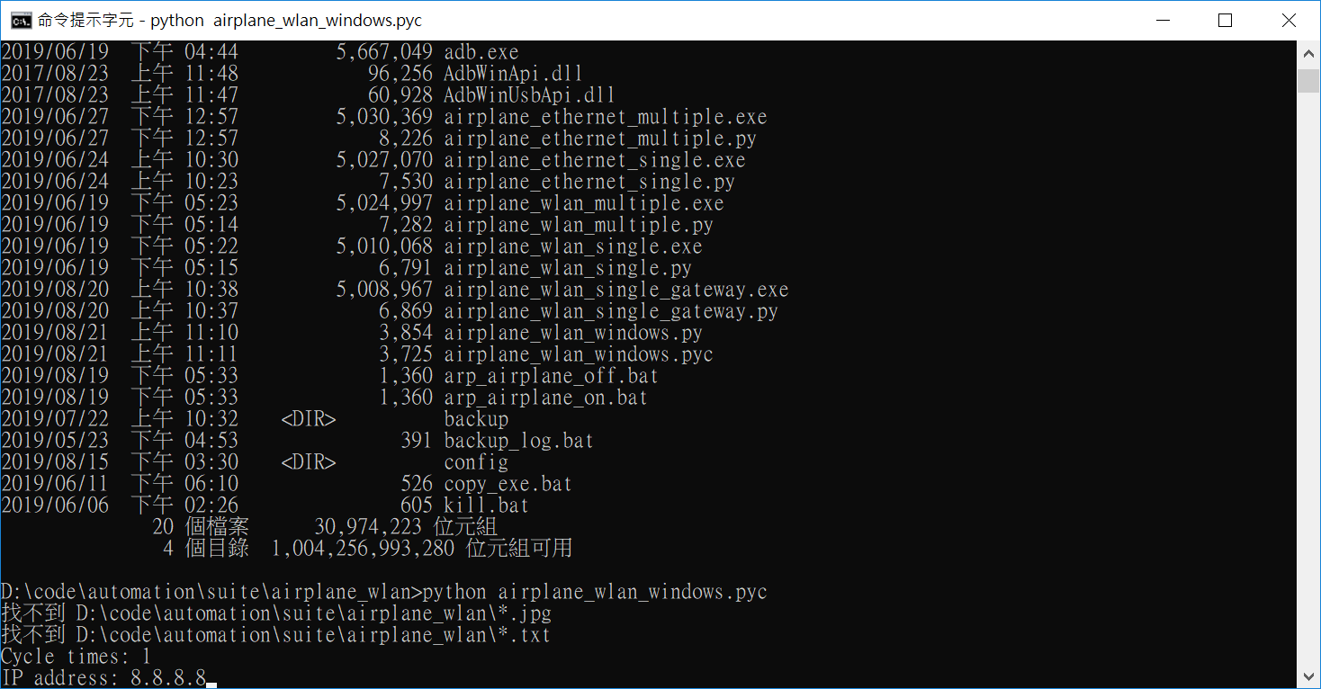

Step 6:

When the program is completed, the windows should be closed.

You can see the log under the “\airplane_wwan\” folder as below:

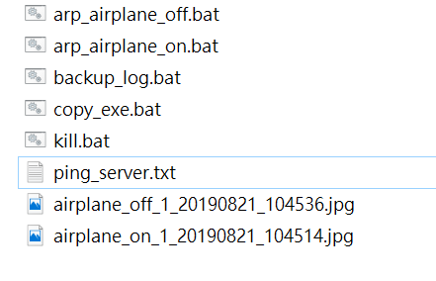

* ping_server.txt is ping log.

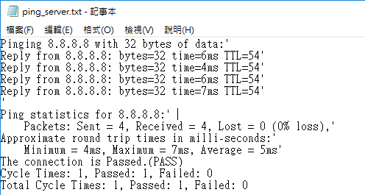

The Total Cycle Times is 1, Passed is 1 and Failed is 0.